
NATIONAL UNIVERSITIES OF MODERN
LANGUAGES
FACULTY OF ENGINEERING AND COMPUTING
DEPARTMENT OF SOFTWARE ENGINEERING

Course Name: WEB-II
Assignment No./ LAB – Task /Project LAB 1: PHP Pagination
Date: 2 Oct, 2025
Submitted by
Class: BSSE (VII) Section - Sessions (M/A) Afternoon
Name: Zulqarnain Hassan Roll No. Sp-21379
Submitted to
Instructor Name: Mr. Danish
To be filled by Instructor
Instructor Comments:
Marks Obtained: Total Marks:
CLO No. :

LAB 1: PHP Pagination

- Create a record of 50 tasks and display the record in 10 pages. Provide the relevant code and output.
2. Style the page links [ 1, 2 ,3 ,4 …] with different hover effects.

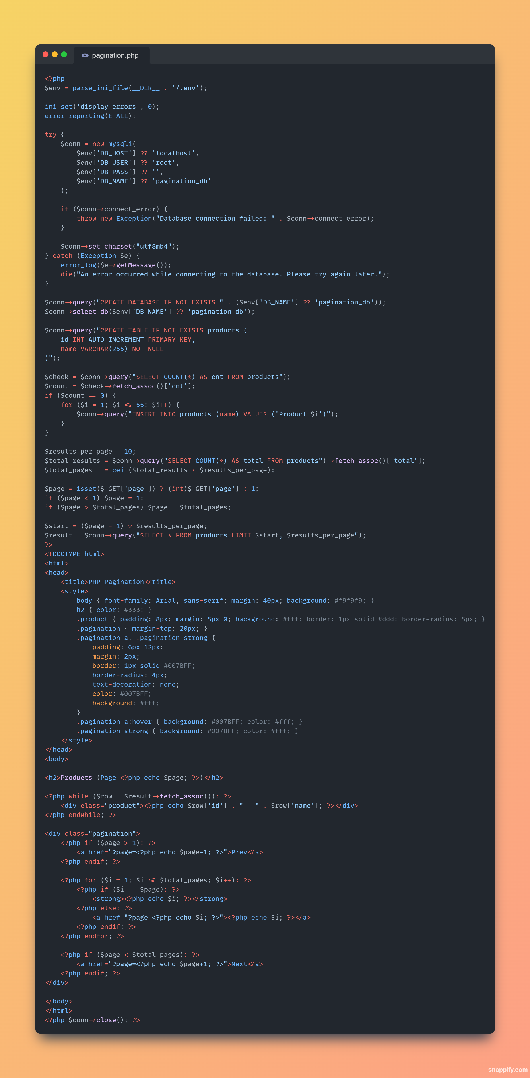
Output:
